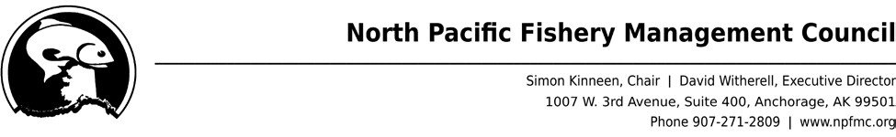

November 3, 2022

Ms. Stacee Karras
Senior Program Manager
National Academies of Sciences, Engineering, and Medicine
2101 Constitution Ave. NW
Washington, DC 20418
Via email: ckarras@nas.edu

Dear Ms. Karras,

On behalf of the North Pacific Fishery Management Council (NPFMC), I am pleased to nominate Dr. Kate Haapala for the ad hoc Committee of the National Academies of Sciences, Engineering, and Medicine to complete a study to assess whether the distribution of federal fisheries management benefits is equitable. Kate has an exceptional background in fisheries management, political science, environmental policy, and nearly a decade of experience working on equity and environmental justice issues, all of which ensure she will be an asset to the ad hoc Committee.

The NPFMC is one of eight Regional Fishery Management Councils established by the Magnuson-Stevens Fishery Conservation and Management Act, and it is responsible for making management recommendations for the fisheries in federal waters off Alaska’s coast. While working for the NPFMC, Kate has worked on several projects directly related to the ad hoc Committee. Since 2019, Kate has led the Local Knowledge, Traditional Knowledge, and Subsistence Taskforce. This is a nominated body of Indigenous and non-indigenous issue experts tasked with developing new protocols and processes for incorporating Local and Traditional Knowledge systems and experts into decision-making. Equity is at the core of this work as is determining the requisite data, information, and expertise.

Kate is currently a nominated member of the NPFMC’s Social Science Planning Team, a body established to improve the quality and application of social science data that informs management decision-making and program evaluation. Kate is also a member of the Council Coordinating Committee’s Equity and Environmental Justice Workgroup, a cross-regional body composed of Council staff working closely with NOAA Fisheries staff. As part of the Workgroup effort, Kate is working to identify regionally specific, and national, pathways for improving equity and environmental justice in federal fishery management processes. Kate is also the staff lead on the NPFMC Community Engagement Committee, which is working to identify and recommend strategies for the Council to provide effective community engagement with rural and Alaska Native communities. Finally, Kate has meaningfully contributed to a variety of social and economic analyses for actions on commercial bycatch reductions, stock rebuilding plans, commercial and for-hire fishery allocations, and more.

Prior to working for the NPFMC, Kate held multiple roles as a Research Fellow and Assistant and Purdue University. Her research examined the interactions between norms, institutions, and justice in global environmental governance with a focus on Indigenous Peoples and fishery management. Her work examined the ways in which multispecies catch share programs in the North Pacific included equity and environmental justice considerations into their designs. She has also worked on collaborative ethnography teams to explore how an Indigenous politics of justice and representation unfolds form within sites of global environmental governance. Her work has been published in the Journal of Peasant Studies, International Environmental Agreements, and more.

We feel Kate has a unique and well-suited background to serve on the ad hoc Committee for three reasons. First, her experience working on staff for the NPFMC would be invaluable as she is uniquely positioned to understand federal commercial fisheries, the types of data currently used to assess the distributional impacts of management actions, as well as the obstacles to collecting and using new sources of information. Second, Kate possesses a demonstrated academic background with the required theoretical and methodological training to work on assessing equity in the distribution of federal fisheries management benefits. Finally, she is no stranger to meaningfully engaging and participating on nominated bodies. The sum of Kate’s experiences would enable her to meaningfully contribute to the ad hoc Committee’s study to determine the categories of information, potential obstacles to collecting data, and methodologies NOAA Fisheries could use to assess equity in the distribution of fisheries management benefits.

Sincerely,

David Witherell
Executive Director

