
NPFMC Power Point Guide


Do
- Use templates
  - This includes when inserting new slides. This makes 508 compliance much easier.
  - It’s ok to change the theme, just make sure to use all the same theme throughout the ppt.
  - This includes template fonts!
- Minimum size 16 font on slides
- Slides should have “pg#” and small logo on ALL slides (title page only exception)
- Title page should have NPFMC logo, author’s names, date, and agenda item on it
FOR MAY, INCLUDE A PHOTO OF THE PRESENTER
- Have a conclusion page with name, logo, website, and contact info
Example Title Slide
FOR MAY, END ON COUNCIL ACTION SLIDE
- Add alt text to images or mark them as background images

- Insert tables as Excel tables
- Use SmartArt when possible for charts/other

Do Not
- No animations or slide transformations
  - This is a 508 rule - I’m not trying to rain on your parade
- No exclamation points (!!!)
- No text boxes to your slide
  - If you need more text boxes use a different slide template
- No charts and graphs as pictures
  - Unless you are really struggling to insert it then you can, but make sure there is alt text explaining the chart
Example Blank Template Slide
- No more than 5 colors from your theme
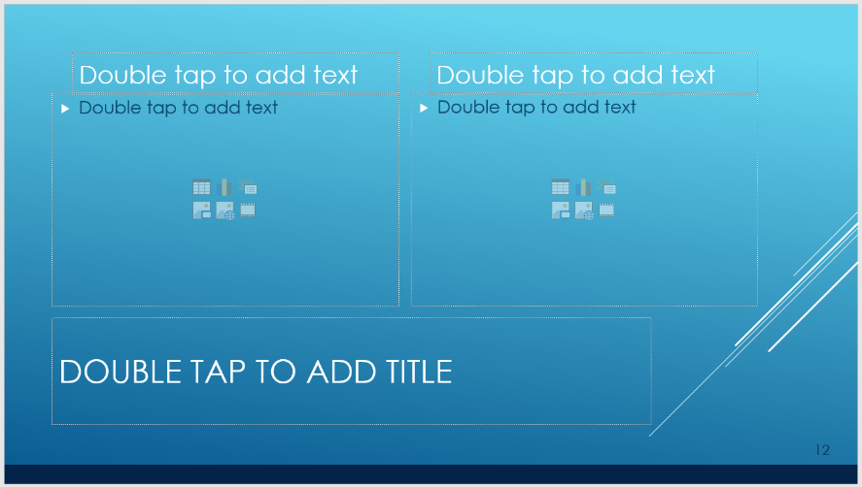
  - This doesn’t include colors within your chart
Best Practice
- When inserting a slide, chose one of the premade slides from your template. They are already constructed tastefully with correct font size and text order for 508.
- If using light text on a dark background, make font 2-3 sizes larger
- Click on icons to insert items in blank slide.
- Printed colors look different than computer colors, if printing double check quality (may need to lighten colors for printing).

General Public NPFMC Power Point Guide

- Use 18-point font or larger on your slides
- Have a title page with your name/organization and agenda item
- Use numbers on your slides (page #)
- Have a slide with contact information at the end
- Send your PowerPoint to npfmc.admin@noaa.gov by 5pm the day BEFORE you plan on presenting to upload for the meeting
  - BUT FOR MAY 2020, SEE SPECIAL GUIDANCE BELOW

Additional Guidance for May and June virtual meeting
- Please have your PPTs to us by the deadline - COB Wednesday 5/13 if possible. We need to post them and to upload them to the virtual agenda, which cannot be done in-meeting.
- As all materials will have been posted in advance, you can keep the presentation really focused and to the point. We were roughly thinking about 10 minutes each for the two B items, and 2-4 minutes each for the C items, but let me know if this is un/reasonable.
- You might want to think about pre-recording your audio. Let us know if you want a HOW TO guide.
It’s straightforward to record directly in ppt, and then you have the presentation done in advance and only have to respond live to questions (this would reduce the risk of a technology glitch messing with the flow of the meeting). If you're not going to pre-record, please come up with a script so that you stay focused.
- Slides should have presenter’s photo, especially for May, as we won’t be using video.
- Have your final slide be a summary of the Council's potential action related to that issue. That way we can keep the final slide posted during the Q&A, and it will hopefully focus the Council on their task.

